________________________________________________________________________________________

OMAG STICK PACKAGING MACHINE mod. DIVA/5 for sugar packing 2012

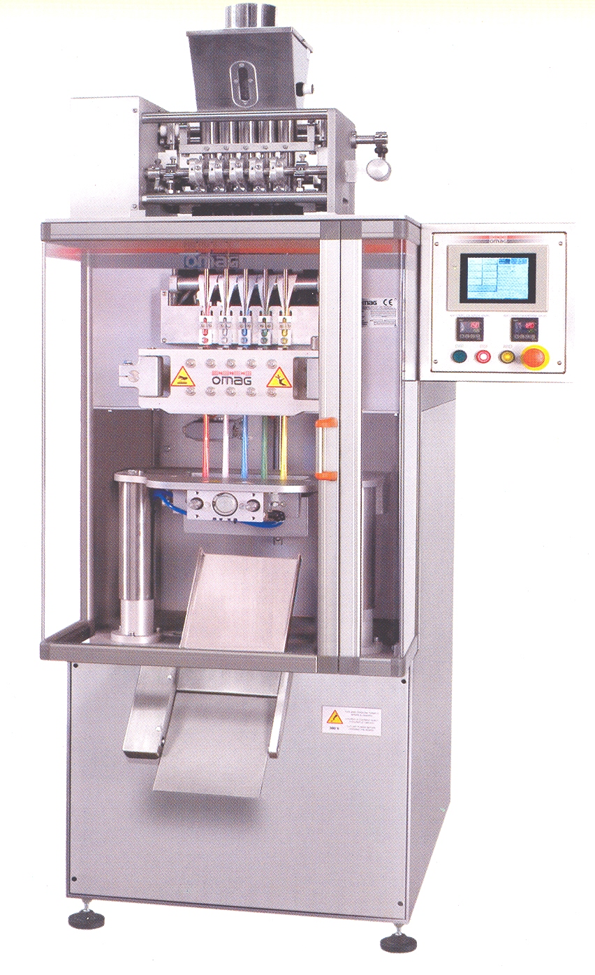

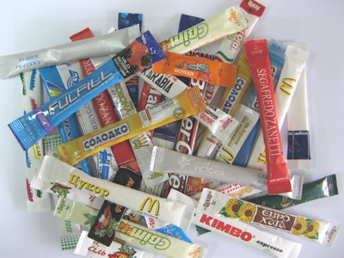

SPECIFICATION, TECHNICAL CHARACTERISTIC

The OMAG DIVA/5 works from one reel of packaging material cuts it into 5 stripes and performs stick sealing from the three sides. The machine is operating on 5 lines.

Specification

Product: Surar, can sugar

Doze: 3-6 gr.

Dozing system: RECIPROCATING & OSCILLATING FILLER

Stick size: width – fixed 17 mm
length - adjustable 60-135 mm
for example,
17 x 110 mm

OUTPUT: 50 – 60 bags/min 1 line equal to 250 - 300 bags/min on 5 lines (to be confirmed after the test of Client’s product and packaging material)

PACKAGING MATERIAL:

Laminated heat sealable packaging materials, suitable for impulse motion packaging machines, is to be tested.
For example: paper kraft + pe, 45+15 g/m2
TECHNICAL CHARACRERISTICS:
INTERMITTENT MOTION VERTICAL PACKAGING MACHINE mod. OMAG DIVA/5 for 3 side thermosealed pouches, in stick pack format.
The machine is provided with 5 packaging lanes, starts from one reel of heatsealable film and can be set according to the following limits:
Stick pack width: fixed.
Stick pack length: 60 135 mm
Max reel width: 220 mm
Fixed, low position support reel holder complete with expansion reel shaft for reels with mm 76.2 core.

Reel vertical cutting group provided with rotating blades.

Foil cutting device provided with two knifes to trim the packaging foil edges.
Swarf removal group.
Vertical sealing group.
Horizontal sealing group.
Horizontal cutting group, "zig zag" style (blades are inserted in the heated, horizontal sealing bars).

Automatic system to preserve the film from sealing temperature during production stops, through temporized detachment of sealing elements.
Temperature electronic controls applied to both vertical and horizontal sealing elements, complete with signal alarm and machine automatic stop in case of out of range values.

System, placed below cutting group, to manage empty/filled sachets flow.

Electronic machine. TOUCH SCREEN keyboard with alarms display and auto diagnosis.
This system allows to set/update the machine synchronism and to store several work programs.

Accident protection guards compliant with with CE norms.
Required electric power: three phase 220/380 V, 50 60 Hz.
Required compressed air: 6 Atm.
Frame in welded steel and painted with epoxy resin paint.

Colour code: RAL 9006 (OMAG standard).

ITEMIZED
LIST OF SUPPLY:

081923
OMAG DIVA/5 basic machine , working on 5 lines

PRINT CENTERING DEVICE

RECIPROCATING & OSCILLATING FILLER on 5 lanes:
Product feeding hopper.
Oscillating dosing cups
Dose discharge tubes.
Motorization.
The system is provided with:
Dose adjustment centralized system
Indipendent adjustment of each single dosing cup

Parts in contact with product are made in INOX and/or materials compliant with FDA regulations.
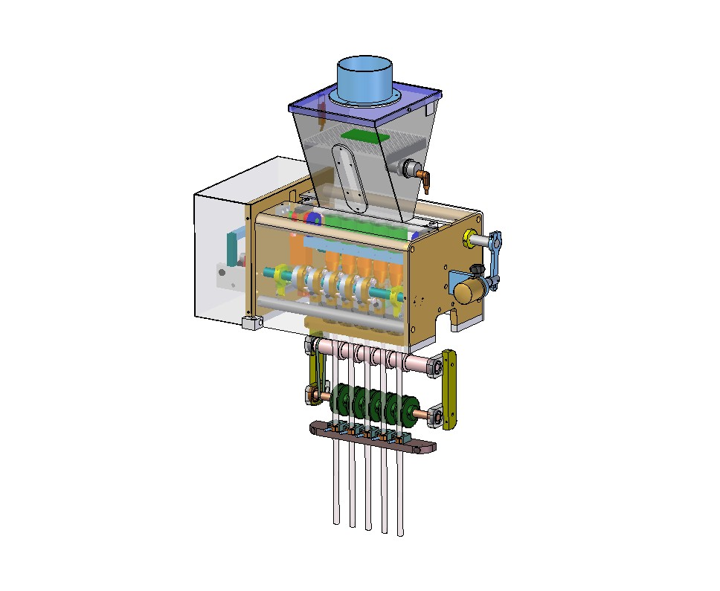

064171
Dust extractor nozzle with N.1 intake manifold and 1 aspirating point for each lane (aspirating unit not included).

Cost of n. 1 STICK packing machine DIVA/5 conditions EX-Works Ukraine

EURO 17 500

Wooden case packing
Еuro 0=

OPTIONS INCLUDED:
066800
Level sensor specifically designedfor granular/powdery productsl
TO COMMAND HOPPER FEEDING SYSTEM
Level switch into the machine hopper to be connected to a product automatic loading system. It commands the machine stop in case of lack of product inside the hopper.
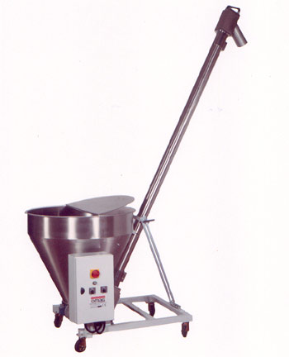

Ground hopper with screw elevator Mod.E/CB for automatic feed of product to the packaging machine infeed hopper.
E/CB hopper capacity: 250 l.
Stainless steel execution.

AUTOMATIC SYSTEM OF PLACING SACHETS IN CARTONS IN BULK

• B3 system for stacking sachets in a caron boxes in bulk (with a vibrator for uniform filling of boxes) with automatic changing of boxes by moving the platform
INCLUDEPICTURE "C:\\Users\\agp.kov\\Documents\\media\\image2.jpeg" \* MERGEFORMATINET INCLUDEPICTURE "C:\\Users\\agp.kov\\Documents\\media\\image2.jpeg" \* MERGEFORMATINET INCLUDEPICTURE "C:\\Users\\Ярослав\\AppData\\Local\\Microsoft\\Windows\\INetCache\\agp.kov\\Documents\\media\\image2.jpeg" \* MERGEFORMATINET INCLUDEPICTURE "C:\\Users\\pak.oms\\AppData\\Local\\Microsoft\\Windows\\INetCache\\Content.Outlook\\AppData\\Local\\Microsoft\\Windows\\INetCache\\agp.kov\\Documents\\media\\image2.jpeg" \* MERGEFORMATINET INCLUDEPICTURE "C:\\Users\\pak.oms\\AppData\\Local\\Microsoft\\Windows\\INetCache\\Content.Outlook\\AppData\\Local\\Microsoft\\Windows\\INetCache\\agp.kov\\Documents\\media\\image2.jpeg" \* MERGEFORMATINET INCLUDEPICTURE "C:\\Users\\pak.nsk\\AppData\\Local\\Microsoft\\Windows\\INetCache\\Content.Outlook\\AppData\\Local\\Microsoft\\Windows\\INetCache\\Content.Outlook\\AppData\\Local\\Microsoft\\Windows\\INetCache\\agp.kov\\Documents\\media\\image2.jpeg" \* MERGEFORMATINET INCLUDEPICTURE "http://portal.ascania.local/sites/group/pack/manufacture/projects/AppData/Local/Microsoft/Windows/INetCache/Content.Outlook/AppData/Local/Microsoft/Windows/INetCache/Content.Outlook/AppData/Local/Microsoft/Windows/INetCache/agp.kov/Documents/media/image2.jpeg" \* MERGEFORMATINET 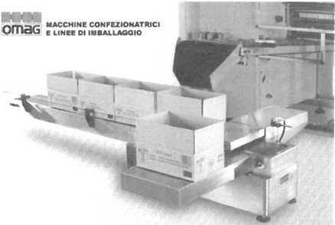
• “FLAP” system - a flap with a counter that allows you to unload the set number of packets into the corrugated box, and then change the unloading point
• Connecting conveyor between the packaging machine and the B3 stacking system

64423
Packing on pallet, for screw elevator E/CB, Ex worksg

